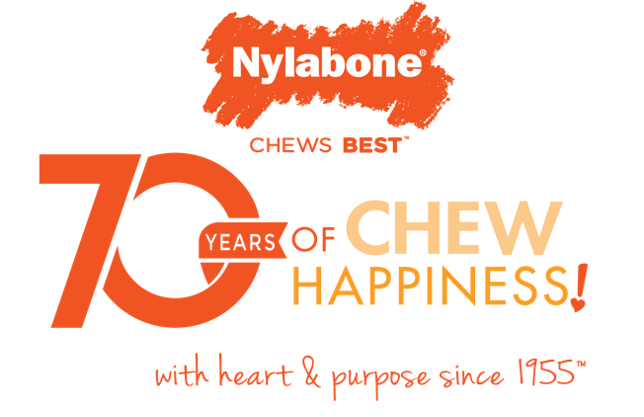
Nylabone Turns 70 and Celebrates by Promoting Dog Adoptions and Helping Homeless Dogs Find Loving Homes

Year-long Celebration Kicks-off with CHEWS for Good™ Campaign On February 14th!
Neptune City, NJ– Nylabone®, an iconic brand in the Central Garden & Pet portfolio (NASDAQ: CENT) (NASDAQ: CENTA), is celebrating its 70th birthday in 2025 with a year-long campaign dedicated to its heartfelt mission; helping dogs find and stay in loving homes. As part of this milestone celebration, Nylabone, is partnering with Best Friends Animal Society® to support pet adoptions by providing chew toys that promote healthy chewing habits, reduce anxiety, and increase a dog’s chances of being adopted.

To kick off the celebration, Nylabone is launching the CHEWS for Good™ buy a Nylabone, give a Nylabone initiative. From February 14, 2025 through December 31, 2025, for every Nylabone product purchased, the company will donate an equal number of Nylabone toys to dogs in Best Friends Animal Society-affiliated shelters and rescues–up to a total of 25,000 toys.
“As we celebrate 70 years of making a difference for dogs and their families, we’re proud to continue our mission of improving the lives of homeless dogs,” said Glen S. Axelrod, President and CEO of Nylabone Products. “According to Best Friends Animal Society, 2.5 million dogs entered U.S. shelters in 2023, and 457,000 dogs were surrendered. A 2021 analysis revealed that roughly 11% of dogs surrendered were due to either personality or minor behavior issues, such as destructive chewing. By providing chew toys that reduce anxiety and encourage calm, adoptable behavior, we are helping more dogs find and stay in loving homes.”

How Pet Parents Can Participate

Pet parents can join the CHEWS for Good™ campaign by purchasing a Nylabone product and uploading their receipt to a dedicated landing page, www.nylabonecares.com for a chance to win exciting prizes, including gift cards and a grand prize. Entries can also be submitted by mail. Complete contest rules and details can be found at www.nylabonecares.com.

Partnering with Best Friends Animal Society
To ensure that all donations reach the shelters and rescues that need them the most, Nylabone is collaborating with Best Friends Animal Society, a national leader in animal welfare dedicated to making the country no-kill in 2025. Best Friends operates lifesaving programs nationwide and runs the largest no-kill animal sanctuary in the U.S., working with a network of more than 5,000 animal welfare organizations and shelters.

“We’re proud to partner with Best Friends Animal Society to help improve the lives of shelter dogs,” said Kim Cassar, Senior Vice President of Marketing at Nylabone. “By reducing stress and promoting calm behavior, our chew toys help these dogs put their best paw forward, increasing their chances for adoption. That is why we’re proud to introduce our new tagline “Trusted Chew Toys with Heart & Purpose Since 1955™.”
“Our 70th birthday is a significant milestone, and this campaign is a meaningful way to give back to the community,” added Adrienne Maglione, Senior Director of Nylabone. Since its founding in 1955, Nylabone has evolved from publishing pet books to becoming the #1 brand of dog chew toys*. For nearly seven decades, the company has been a trusted leader in creating high-quality chew toys that help dogs relieve boredom, anxiety, and stress while promoting healthy chewing habits.

Limited-Edition Birthday Chew Toys

In honor of its 70th birthday, Nylabone will release a special collection of limited-edition birthday chew toys starting in April 2025. These celebratory products will feature the brand’s signatory orange color, bestselling shapes and flavors and textures designed to help clean teeth and keep dogs entertained.

“As Best Friends works to make every shelter in America no-kill, we’re grateful for the opportunity to partner with Nylabone to help us get there,” said Julie Castle, CEO of Best Friends Animal Society. “Many shelters across the country are struggling with high dog intake numbers, and through this initiative, we can help get more dogs find the loving homes they deserve.”
To learn more about Nylabone and its 70th-birthday, visit www.nylabone.com and follow @Nylabone on YouTube, Facebook, Instagram and TikTok.

About Nylabone®
Nylabone, a leader in healthy chewing since 1955, crafts high-quality chew toys, tasty chew treats, exciting play toys, and innovative dental solutions. A family-founded company, Nylabone has a history of helping pet parents take the best possible care of their dogs. Nylabone is committed to developing world-class solutions for destructive chewing, separation anxiety, dental health, and more, helping dogs live fuller, happier lives. Recommended by veterinarians, Nylabone® products encourage a positive relationship between humans and their furry best friends. To put it simply, Nylabone® Chews Best™! Visit www.Nylabone®.com to learn more. Nylabone is a brand owned by T.F.H. Publications, Inc. T.F.H. Publications, Inc. is a subsidiary of California-based Central Garden & Pet Company (NASDAQ: CENT) (NASDAQ: CENTA) and has been a leader in responsible animal care for over 65 years.

*Based on Nielsen data 11/20/2024

Media Contact
press@central.com
925-412-6726

Source: Nylabone

